Contact:
Lindsey Newcomb, Marketing Manager
newcombl@ahtcorp.com
(319) 291-3409

Advanced Heat Treat Corp.® Increases Capacity at Alabama Location with Additional Induction Hardening and Gas Nitriding Equipment

CULLMAN, AL – March 9, 2026 – Advanced Heat Treat Corp.® (AHT), a recognized leader in heat treat services and metallurgical solutions, has invested in two additional pieces of equipment at its Cullman, Alabama location. The equipment will expand capacity for induction hardening and gas nitriding, supporting increased production volumes, faster turnaround times, and more complex part geometries.

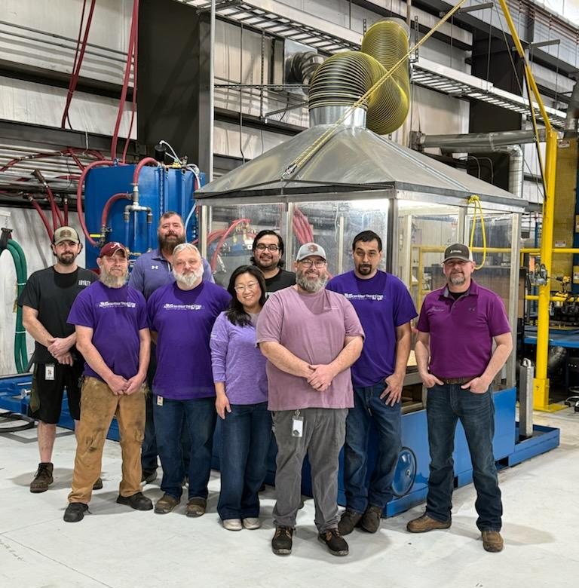
The Alabama location recently installed a larger induction hardening unit to support continued growth in customer demand. The new system accommodates parts up to 60 inches in diameter and more complex part geometries. While earlier systems were primarily suited for cylindrical components such as shafts, gears and pins, the new unit enables induction hardening of more intricate part designs, opening the door to a broader mix of applications and industries.

AHT has also expanded gas nitriding capacity with the addition of another nitriding unit, enhancing the site’s ability to support high‑volume nitriding programs while maintaining quick lead times and consistent quality.

“These investments allow us to scale with our customers,” said Tim Garner, AHT plant manager. “We are well-positioned to handle a wide range of part sizes, geometries, and production volumes without compromising turnaround time.”
AHT employees stand in front of the new induction hardening unit in Cullman, Alabama.

Advanced Heat Treat Corp.® operates four locations: one in Cullman, Alabama; two in Waterloo, Iowa; and one in Monroe, Michigan. Across these locations, AHT offers more than 20 surface treatment processes, including ion nitriding, gas nitriding, ferritic nitrocarburizing, UltraOx®, induction hardening, stress relieving, and more.

With a focus on technical expertise, fast response times, and scalable capacity, AHT continues to invest in people, equipment, and processes to meet the evolving needs of manufacturers worldwide.

For more information about Advanced Heat Treat Corp.® and its services, please visit www.ahtcorp.com or call 319-232-5221.

###

About Advanced Heat Treat Corp.
Established in 1981, Advanced Heat Treat Corp. (AHT) is a recognized leader in providing heat treat services and superior metallurgical solutions to companies across the globe, with locations in Alabama, Iowa and Michigan. Their UltraGlow® family of processes includes plasma ion nitriding, ferritic nitrocarburizing (FNC), gas nitriding, UltraOx®, through hardening, carburizing, carbonitriding, induction hardening and many more.

