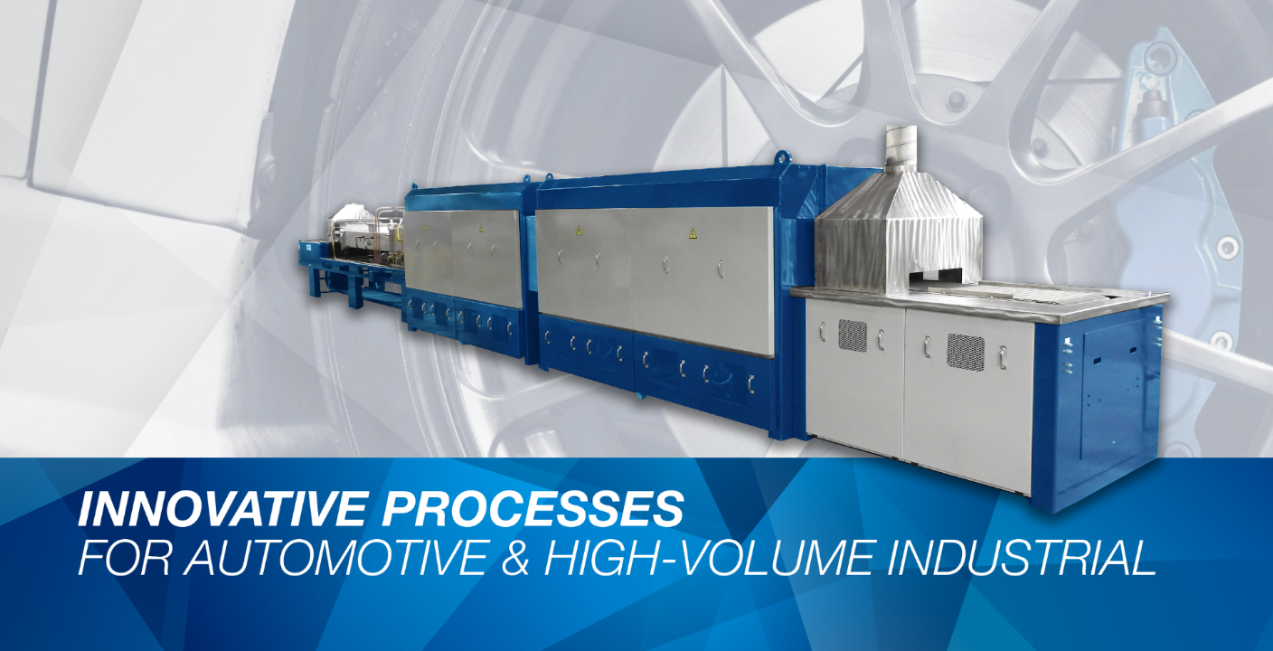
Automotive Supplier Expands Stainless Steel Brazing Capacity with New Gasbarre 24" Belt Furnace Order
St. Marys, PA — Gasbarre Thermal Processing Systems (Gasbarre) has been selected by a long-standing customer to supply a new 24-inch belt, 4-zone brazing furnace supporting automotive component production. The system will be installed at an established Midwest manufacturing facility as the customer expands capacity to meet increased production requirements.
The order represents the customer’s third Gasbarre brazing furnace, building on the success of two existing installations currently supporting day-to-day operations. The new furnace will be used for stainless steel brazing of automotive parts, including braking and fluid line components, where consistent thermal processing and atmosphere control are essential to quality and reliability.
Designed for controlled-atmosphere processing, the system will operate in a nitrogen/hydrogen atmosphere and is engineered to support repeatable brazing results, stable production flow, and operator-friendly use.
The customer selected Gasbarre based on the proven design and performance of its existing furnaces. Prior installations have delivered dependable uptime with minimal issues, while maintaining a clean, accessible layout that operators find easy to use — a key factor when adding capacity in a high-output environment.
“When a customer returns for additional capacity, it’s the strongest validation of reliability and long-term value,” said Ben Gasbarre. “This order reflects the trust we work to earn through durable equipment, repeatable processing, and responsive support.”
Gasbarre Thermal Processing Systems designs and manufactures engineered thermal processing equipment for demanding industrial applications.
To learn more, contact inquiries@gasbarre.com or visit www.gasbarre.com.

