FOR IMMEDIATE RELEASE

Gasbarre Announces Exclusive North American Rights for SOLO Swiss ProfiTherm® Modular Bell Furnace System
Compact layout with minimal infrastructure — and lower lifecycle cost through retort-based processing and simplified internal handling
St. Marys, PA — January 2026 — Gasbarre Thermal Processing Systems (Gasbarre) announced a licensing agreement with SOLO Swiss SA (Porrentruy, Switzerland) granting Gasbarre exclusive rights to promote, sell, and manufacture the SOLO ProfiTherm® heat treating system in North America.
ProfiTherm is a modular arrangement of bell furnaces and quench tanks with direct, rapid transfer from furnace to quench—positioned as a practical alternative to traditional integral quench batch furnaces.
Why ProfiTherm is different for North American heat treaters
1) Compact layout with minimal infrastructure
ProfiTherm’s bell-furnace modular layout supports a more compact system footprint and simplifies installation requirements, reducing plant disruption and the infrastructure scope (no need for pits) often associated with conventional batch systems.
2) Lower operating and maintenance cost — by design
ProfiTherm incorporates a metallic retort that supports fast furnace conditioning and quicker process changeovers, while helping protect refractory from process-gas exposure to improve refractory life. In addition, the design eliminates many traditional internal nickel-alloy material handling wear items (roller rails, chain guides, handler heads) that drive consumable spend and downtime in conventional systems—helping prevent furnace jams and simplifying service access.
Process coverage and applications
ProfiTherm supports key heat treat processes including austempering, marquenching, carburizing, carbonitriding, neutral hardening and more, with quench options including water/polymer, oil, and salt. Target applications include captive heat treat departments and commercial shops supporting general industry, aerospace, defense, and bearing markets.
About Gasbarre Thermal Processing Systems
Based in St. Marys, Pennsylvania, Gasbarre Thermal Processing Systems designs and manufactures thermal processing equipment and provides service and aftermarket support for heat treating operations.
About SOLO Swiss SA
SOLO Swiss SA, headquartered in Porrentruy, Switzerland, designs and manufactures bell furnace systems, including the ProfiTherm product line.
Learn more / Inquiries: www.gasbarre.com | www.soloswiss.com

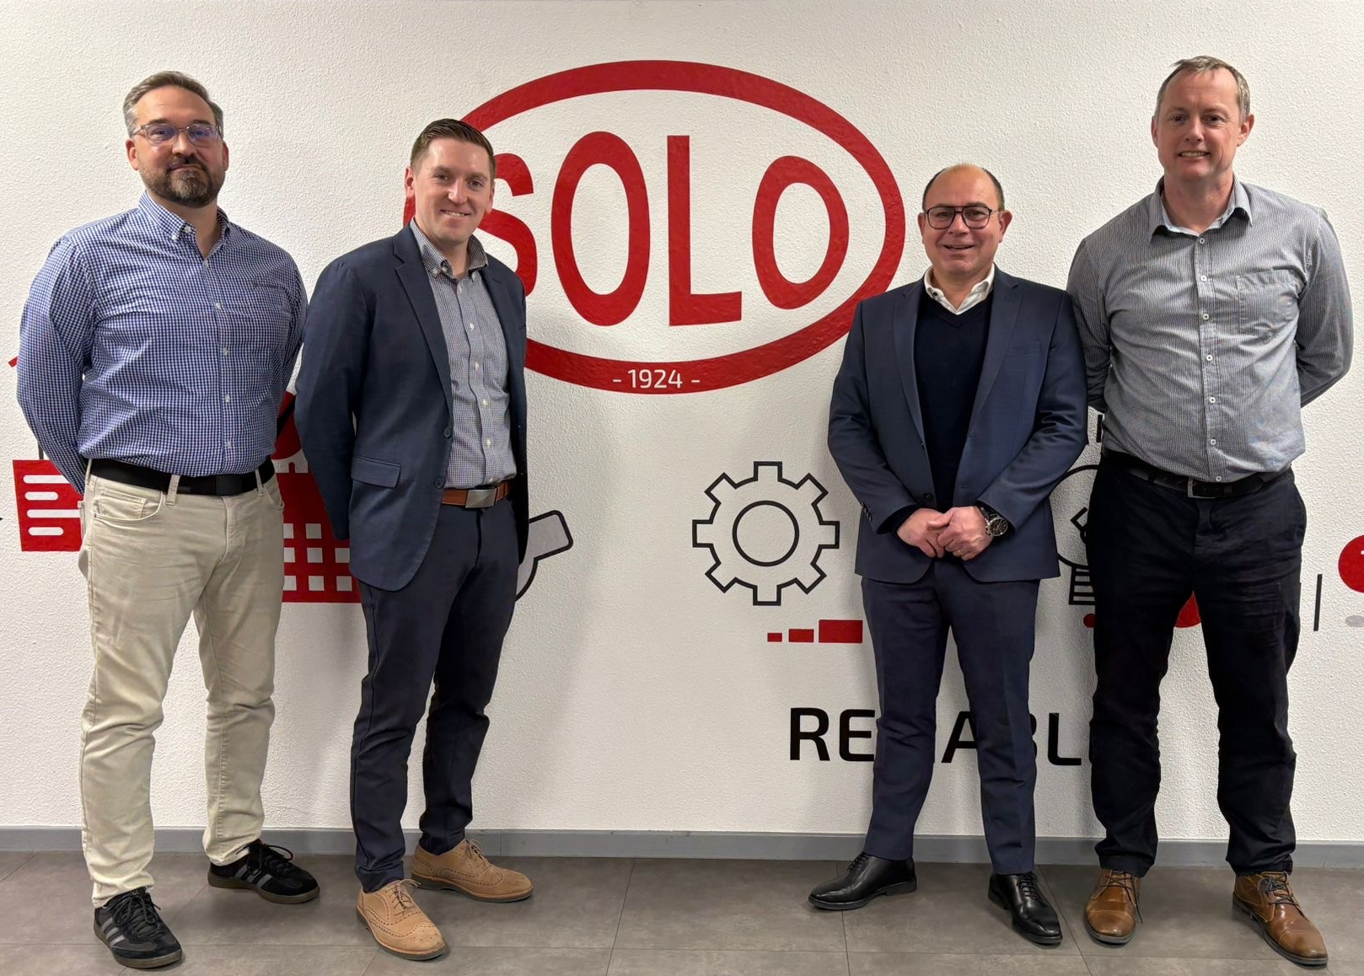
Left to Right: Dan Hill – Gasbarre Product Development Manager; Ben Gasbarre – Gasbarre E.V.P. Sales & Marketing; David Salerno – Solo CEO; David Howard – Solo Sales Director

