6 November 2024
Press Release

Bennett Heat Treating & Brazing Co., Inc. Recognized with 2024 Master Craftsman Award
New Castle, PA | Heat Treat Today, in cooperation with the Metal Treating Institute (MTI), recently presented the 2024 Master Craftsman Award (also known as the Commercial Heat Treater of the Year Award) to John and Kerri Quaglia, third-generation owners of Bennett Heat Treating & Brazing Co., Inc.
The award was presented at the formal awards presentation dinner following the Furnaces North America trade show on October 16, 2024, in Columbus, OH. John Quaglia was present to receive the award on behalf of his company. In his speech, Doug Glenn commented, “This year’s recipient is another shining example of what the commercial heat treating industry has come to represent — highly competent, environmentally aware, and civic-minded leaders in their community and in the heat treating industry — a great example of what commercial heat treating is all about.”
This award is given to the company that demonstrates making a positive impact on their community and their industry. Recognition is based on quality programs, commitment to the environmental, and community leadership and judged by a panel of previous recipients
Bennett Heat Treating received a plaque commemorating this auspicious award and a scholarship fund of $1500 from Heat Treat Today that was matched with another $1500 from MTI’s Education Foundation. The heat treater will award this $3000 to a high school or college student who is pursuing an education in the heat treating industry.
Congratulations to Bennett Heat Treating on receiving this award.

Full-size press images located here.
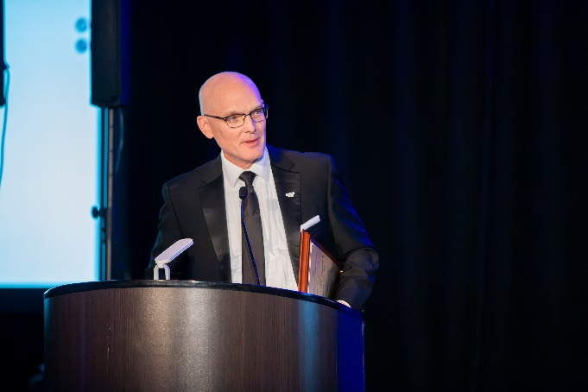
Photo Caption: Presenting the 2024 Master Craftsman Award is Doug Glenn, publisher of Heat Treat Today and treasurer on the Board of MTI’s Education Foundation.
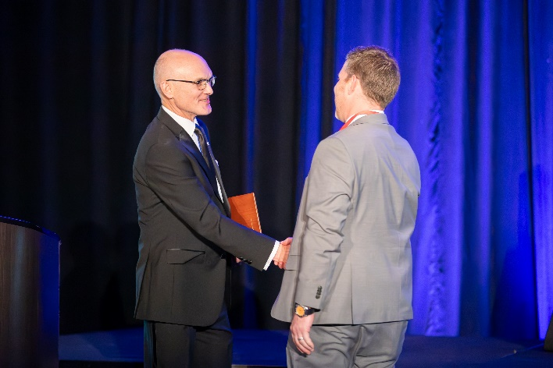
Photo Caption: John Quaglia, co-owner and president of Bennett Heat Treating, accepts the 2024 Master Craftsman Award from Doug Glenn.

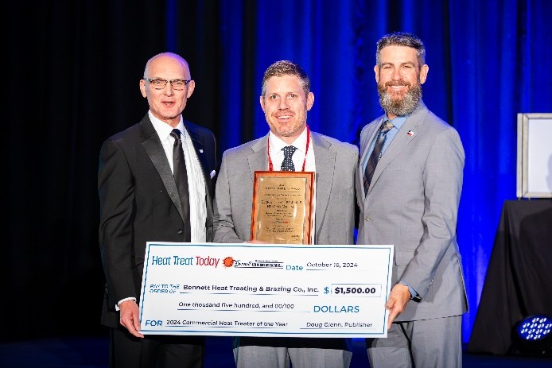
Photo Caption: Scholarship award check presented to Bennett Heat Treating & Brazing Co., Inc. (Left to right) Doug Glenn, publisher of Heat Treat Today; John Quaglia, president and co-owner of Bennett Heat Treating; and Ryan Fussell, president of Southwest Metal Treating Corp and 2024 MTI President.

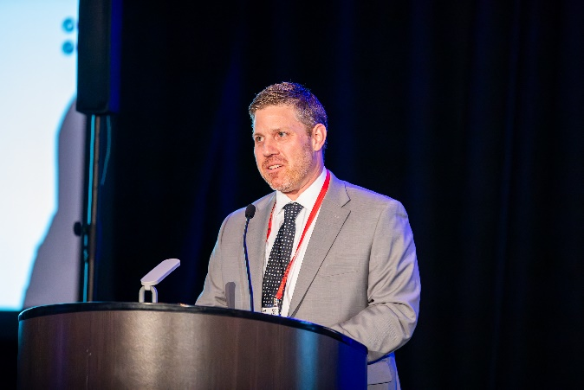
Photo Caption: John Quaglia, co-owner and president of Bennett Heat Treating, speaking upon his company’s receiving the 2024 Master Craftsman Award.

